Testing Steps for Dev Environment
6. Process Steps
[Note: Process Step has directly dependency on sub steps setup]
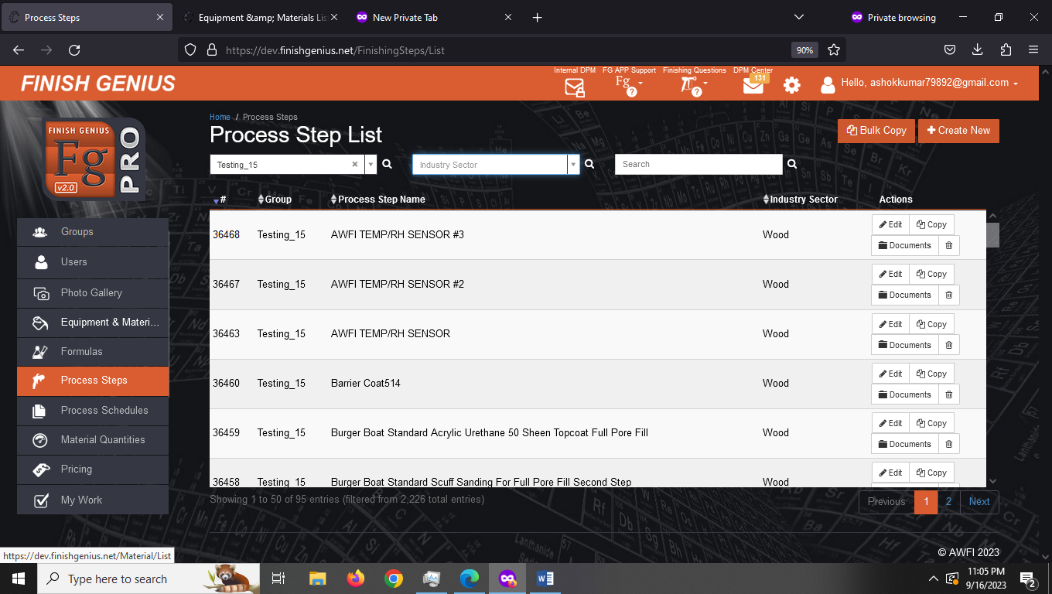

We can see process steps for each group
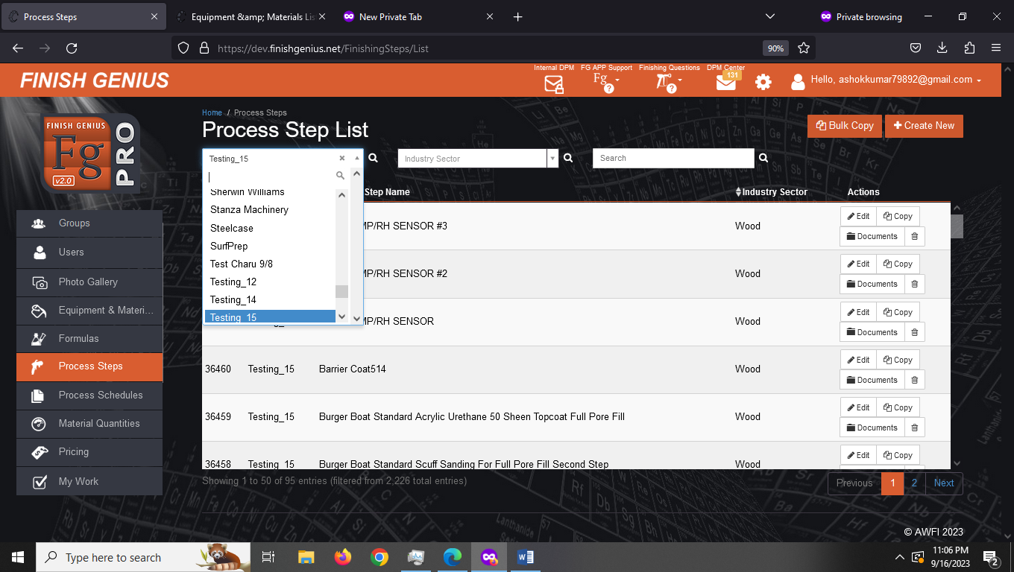
We can see process steps for each group as per Industry Sector
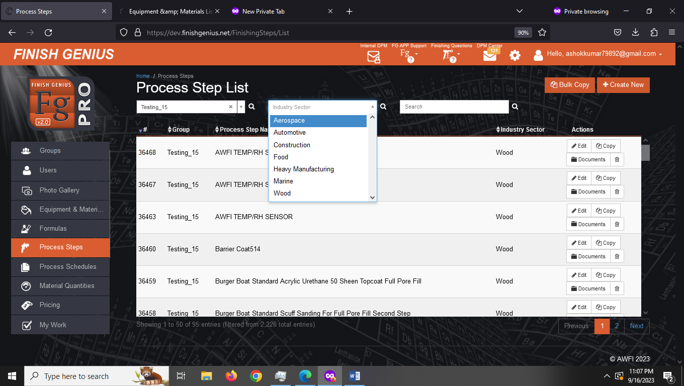
1. Checking all the process steps are same in prod and dev environment
Process: Randomly checked 5 clients all the process steps are same in prod and dev
2. Industries for which we can create process steps are as follows
1. Aerospace
2. Automotive
3. Construction
4. Food
5. Heavy Manufacturing
6. Marine
7. Wood
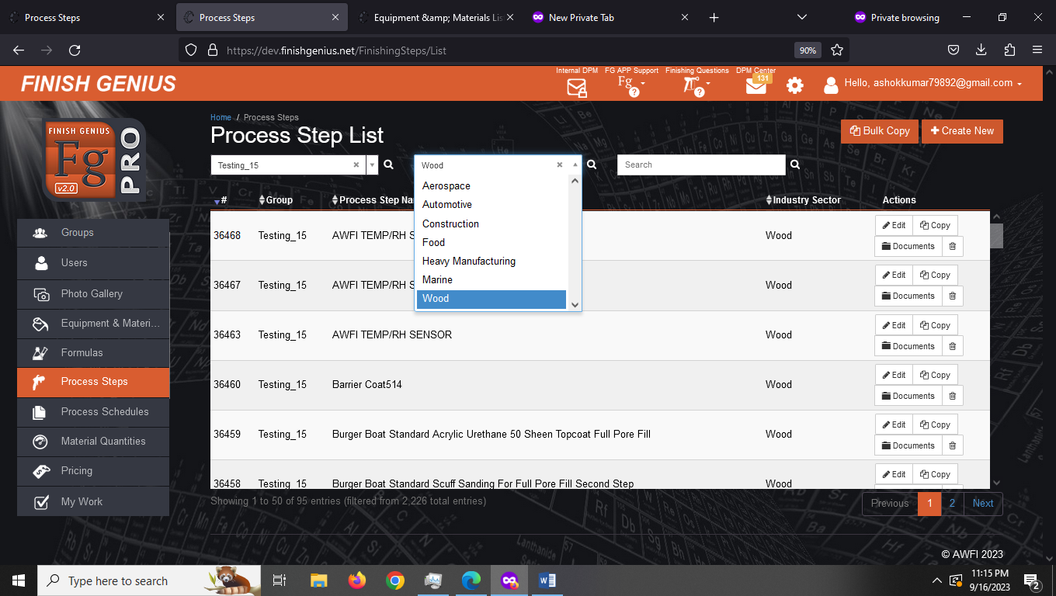

3. Create New Process Steps
3.1 To create Process Steps we first need to create substeps then only we can create Process Steps. So lets first learn how to create substeps.
Step-1
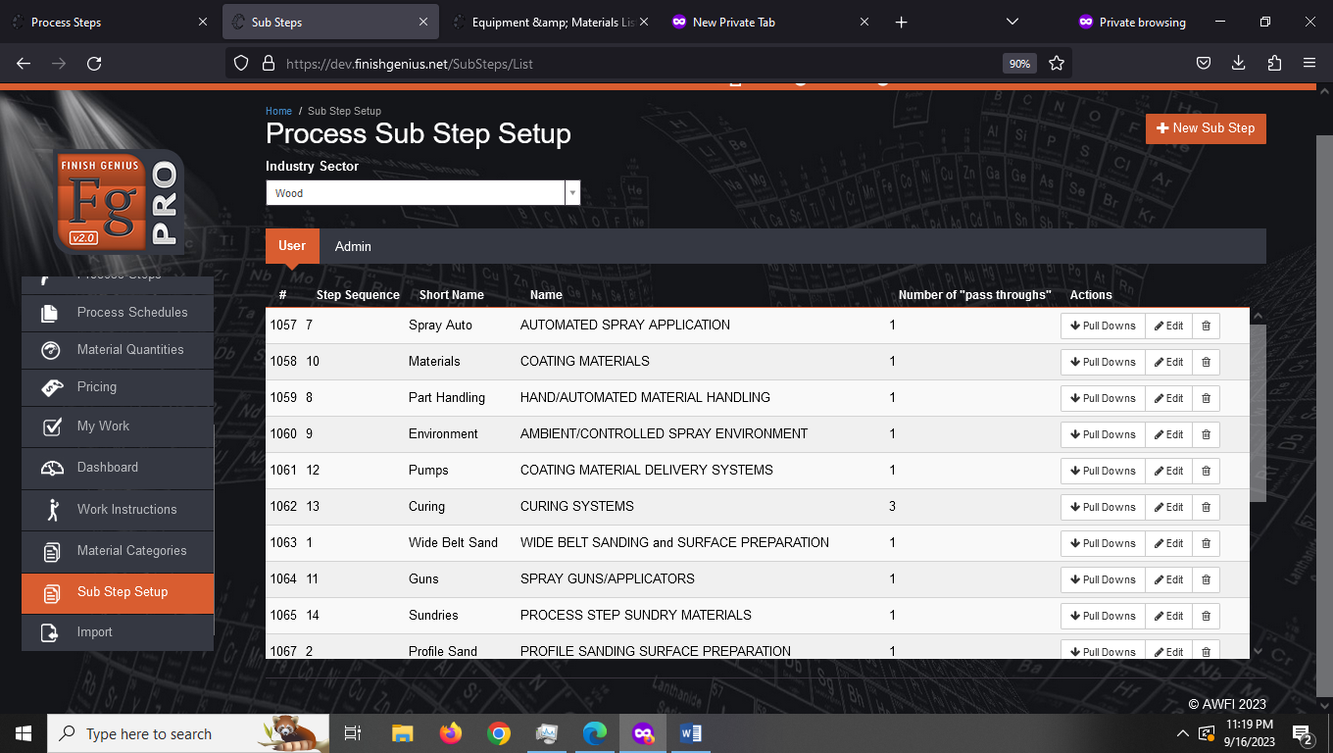

Step-2 Select Industry. For testing purpose we are selecting Aerospace
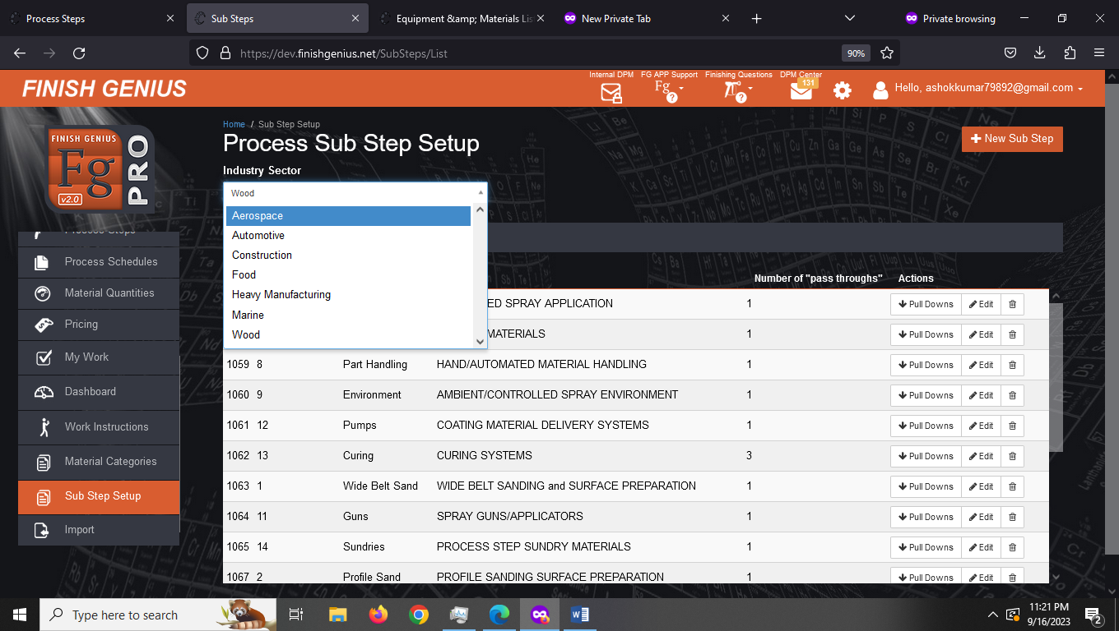
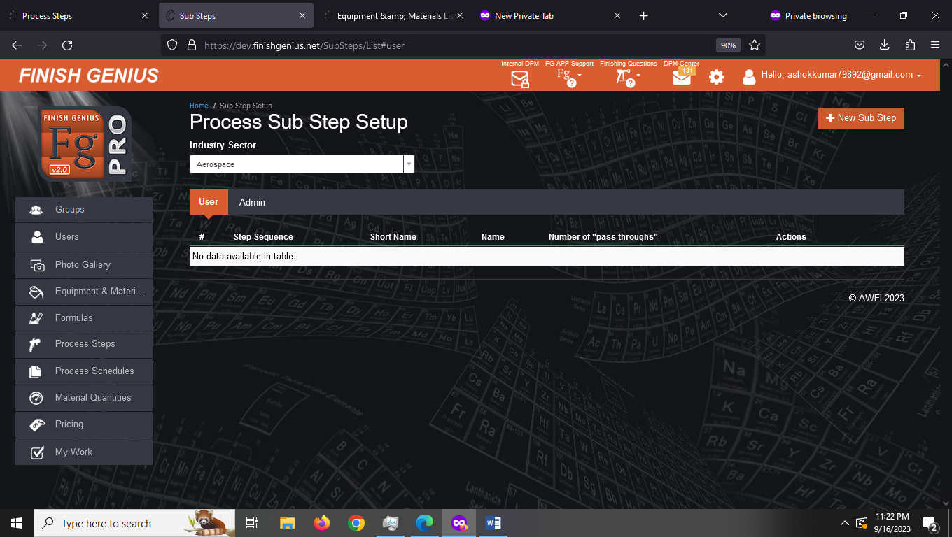

Step-3 Click on New Sub Step
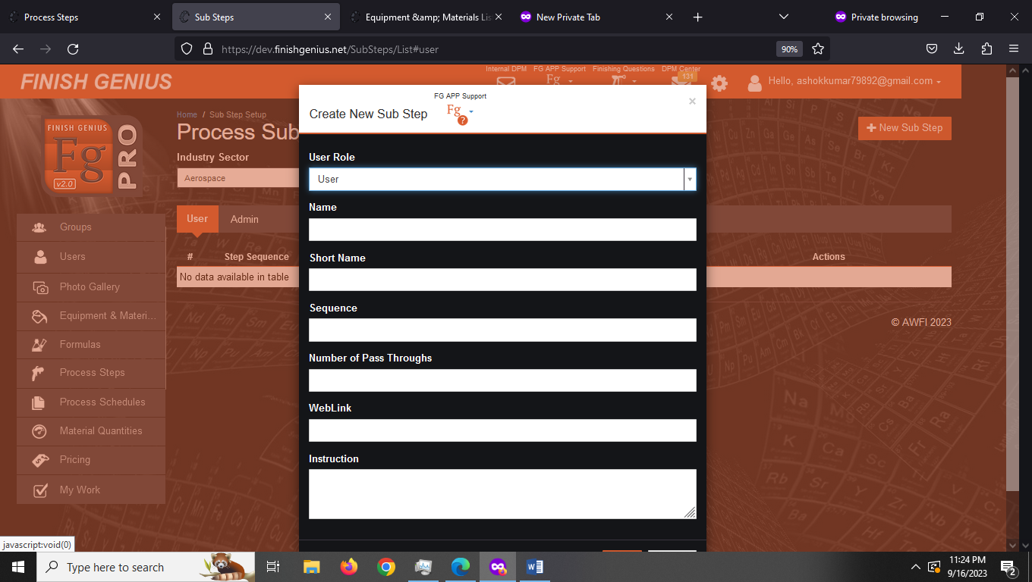

Step-4 You can use role as user or admin and create sub task as follows
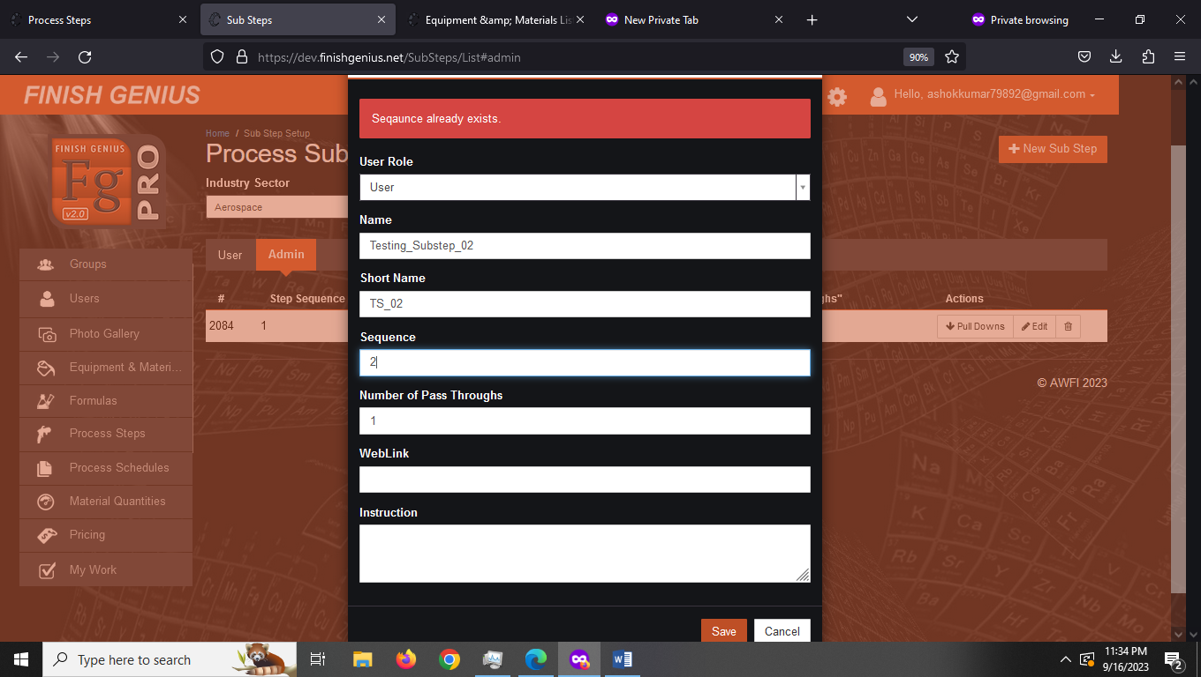
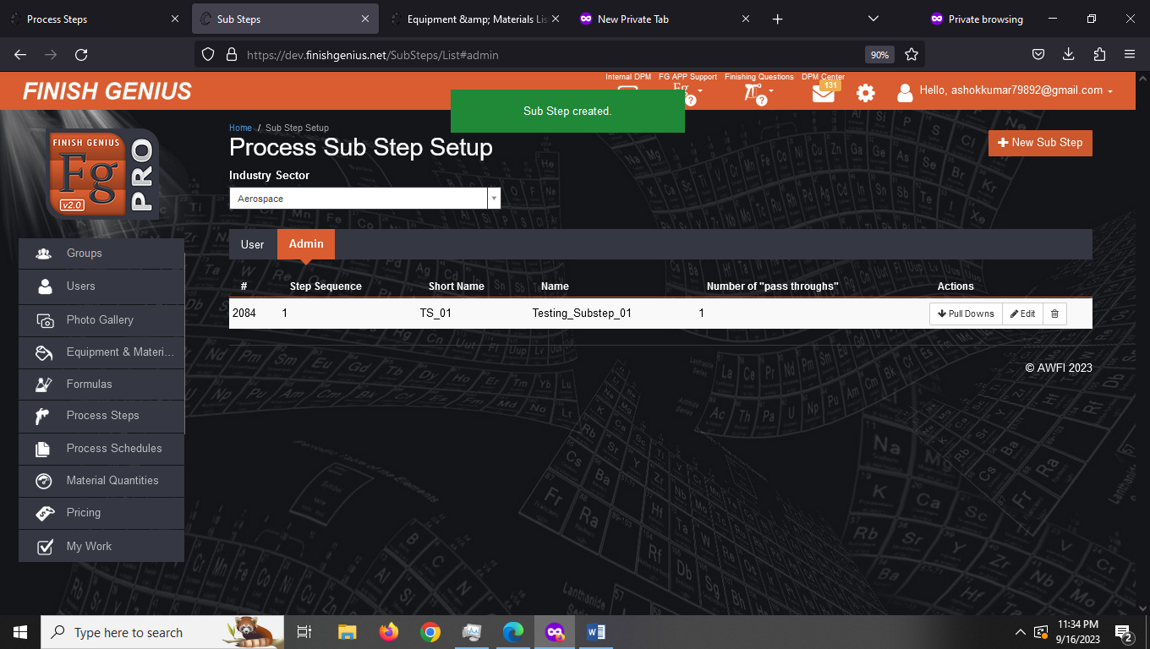

In pull down request we can create query
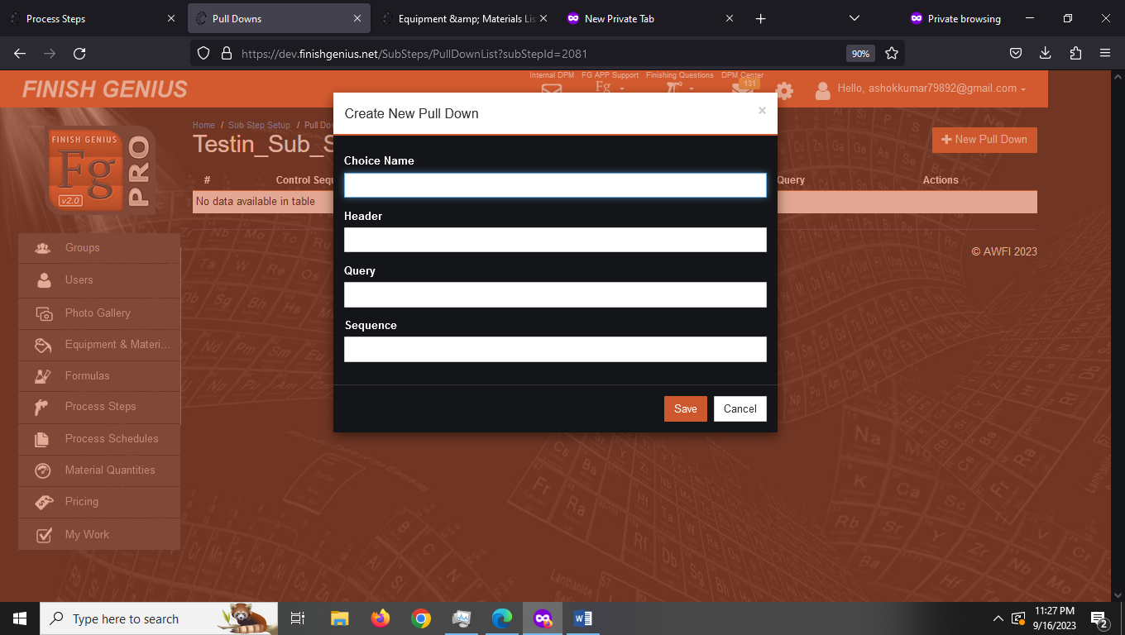
Step-5 Similarly we will create 4 more substeps
Admin Sub Step
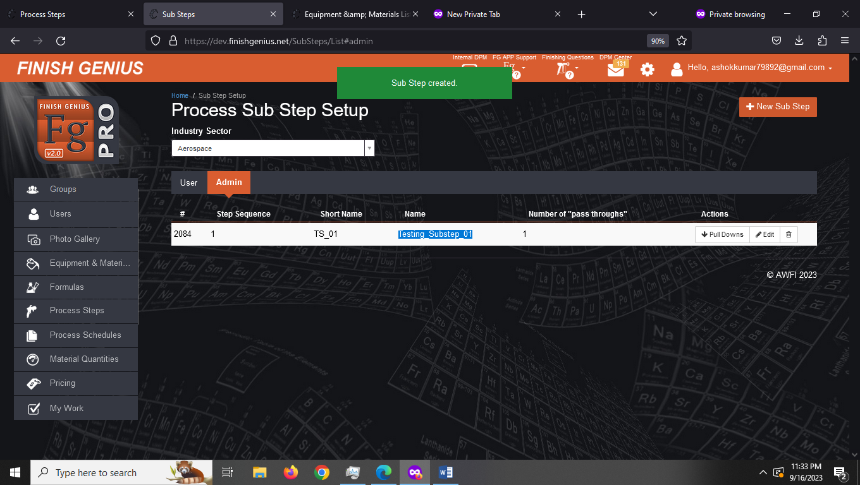

User Sub Step
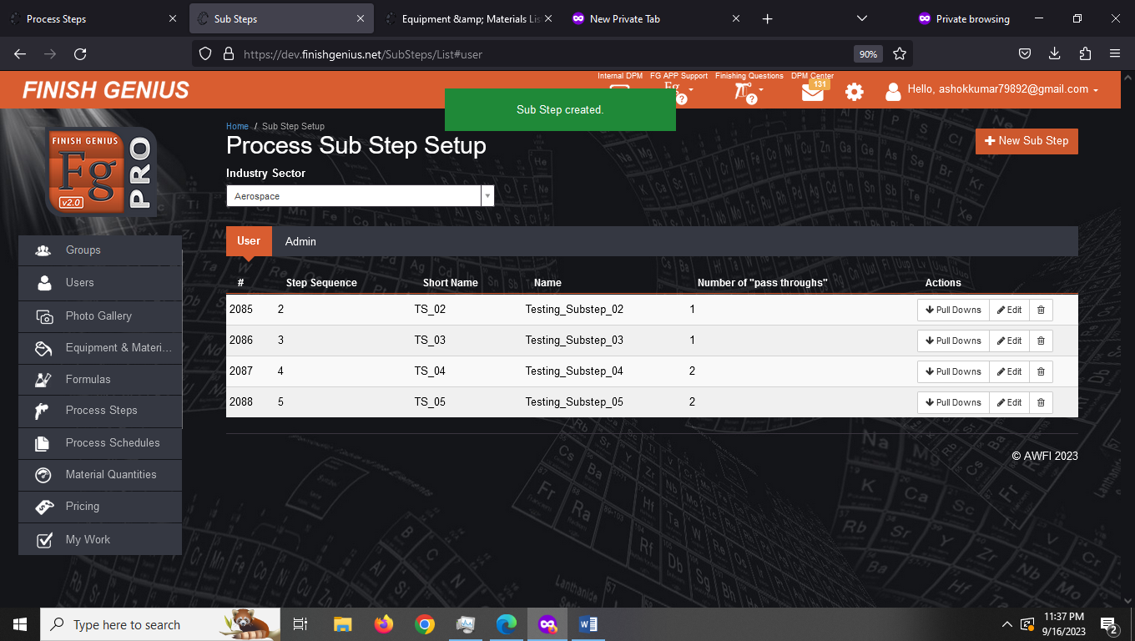

Note: These Sub steps will be visible when we start creating Process Steps

3.2 Create Process Steps
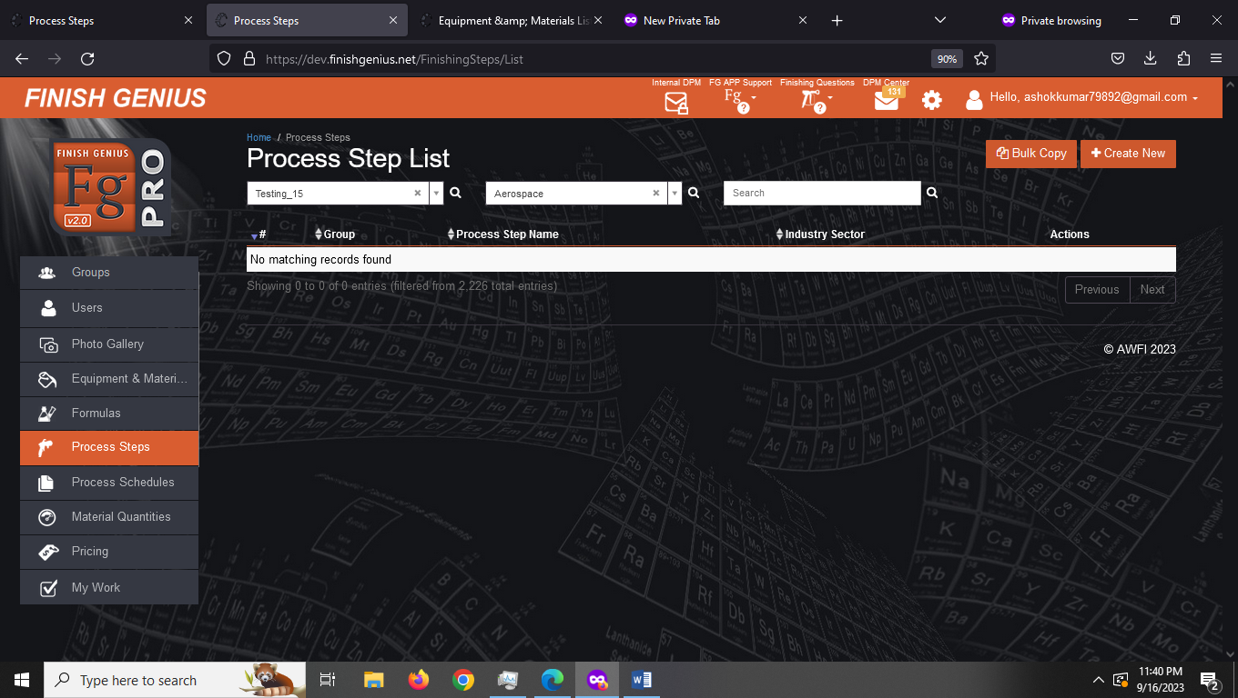
Step-1 Click on Create New

You will observe we are getting the steps created in sub steps here and now we can create PROCESS using this sub step
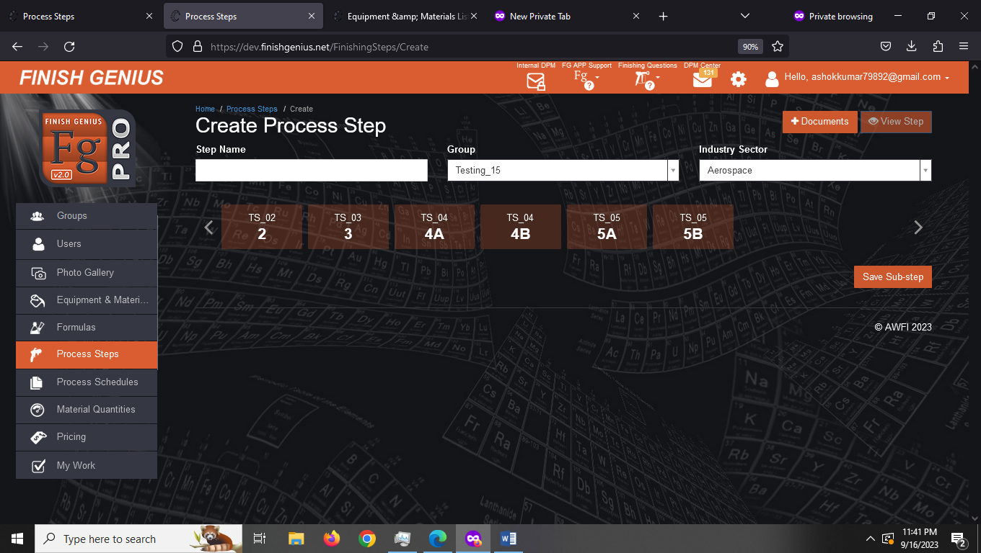
Step -2 Give the name to this Process Step. We are giving it name Testing_Process_Step_01
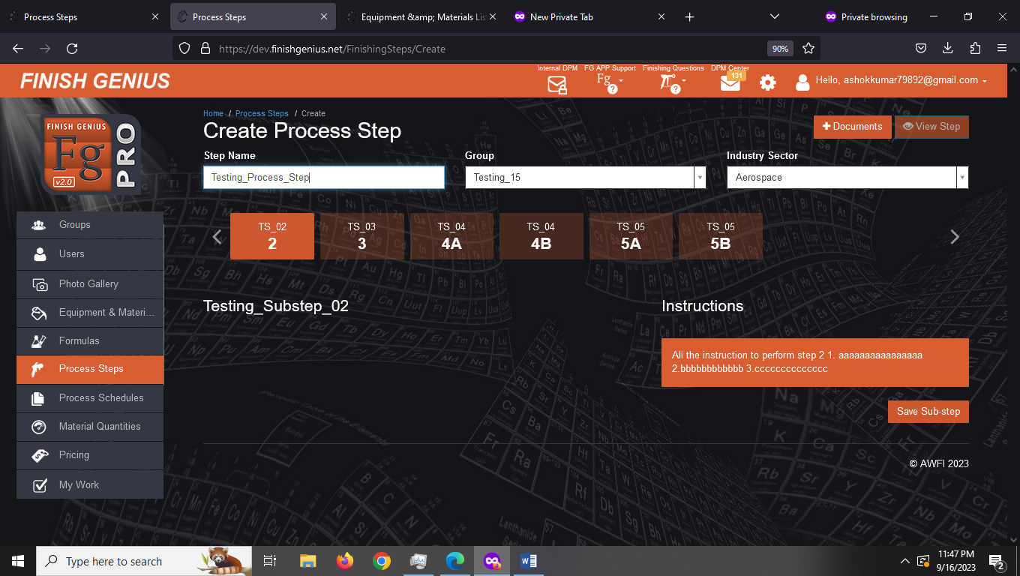

Step-3 Select sub steps you wish to execute and save them
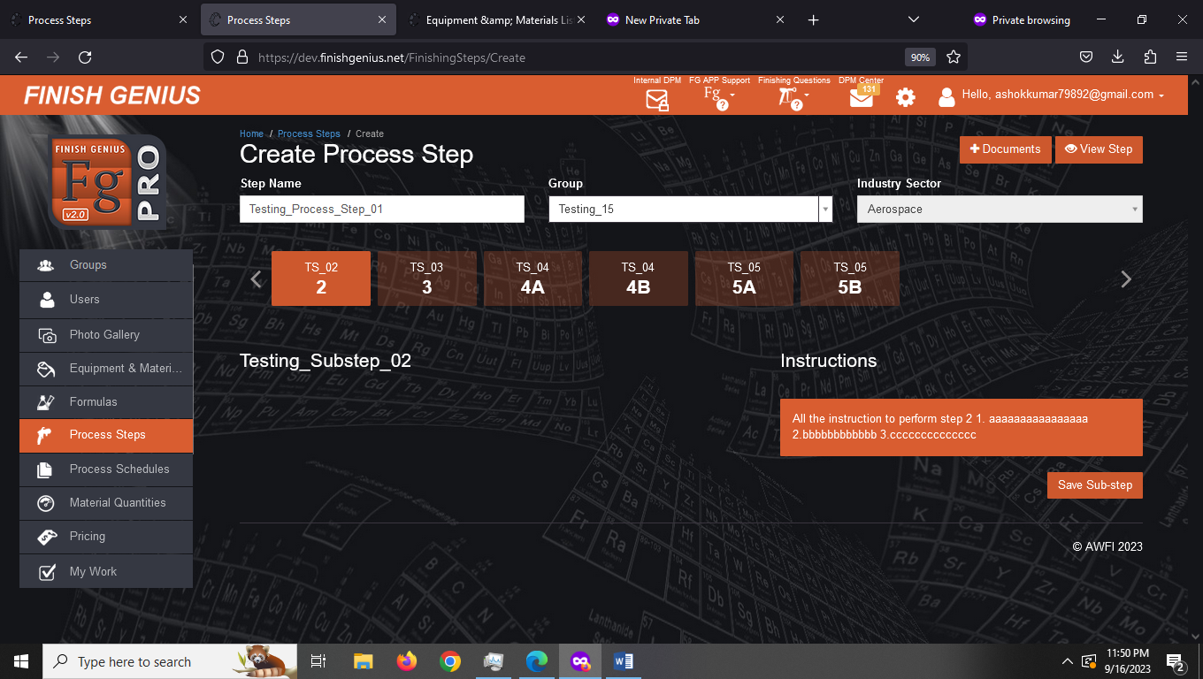
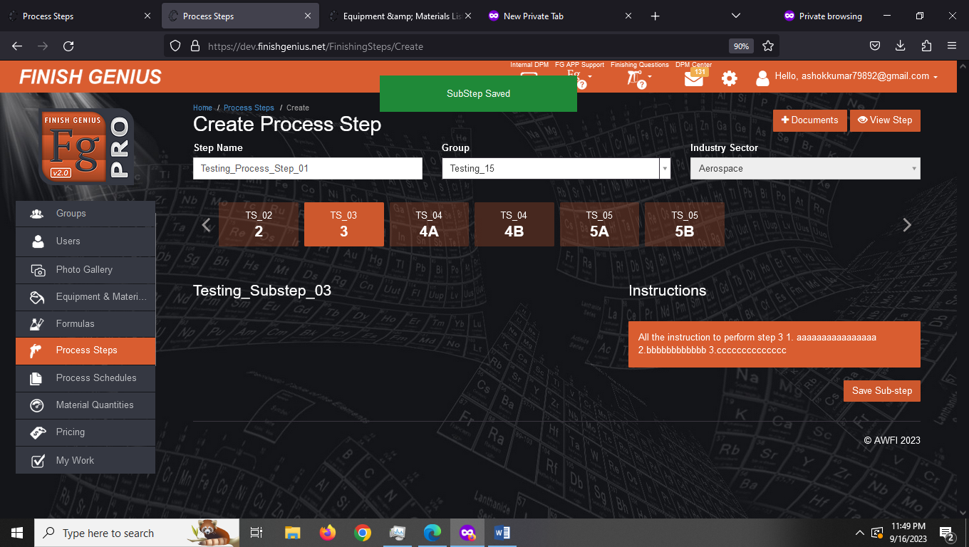
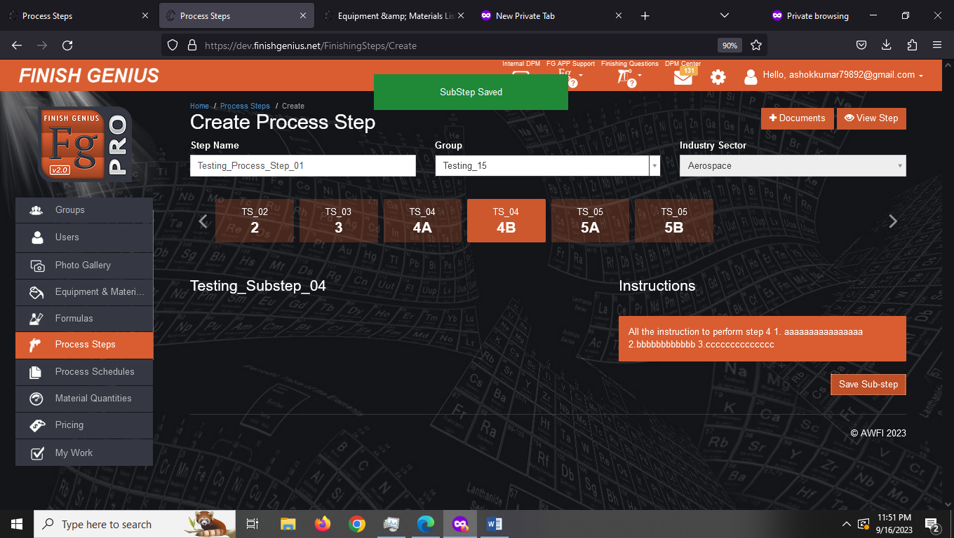

Step-4: View Steps
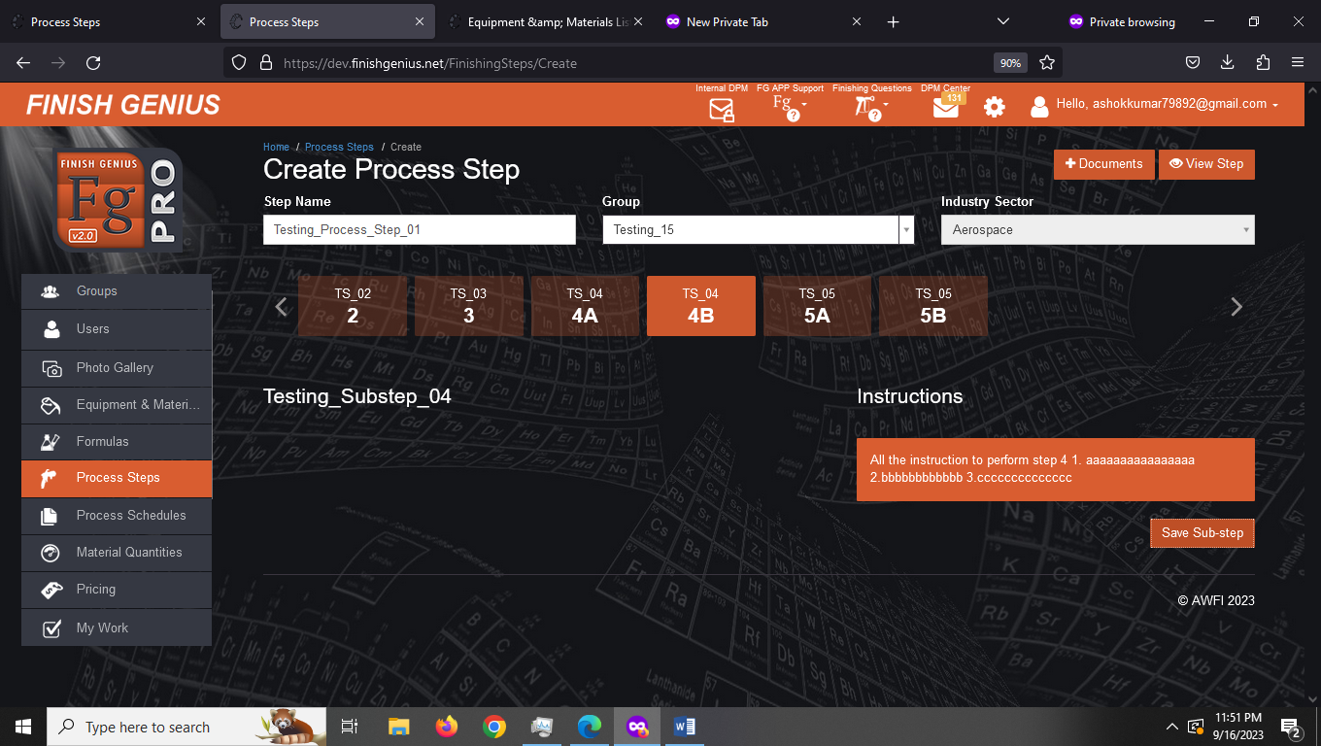
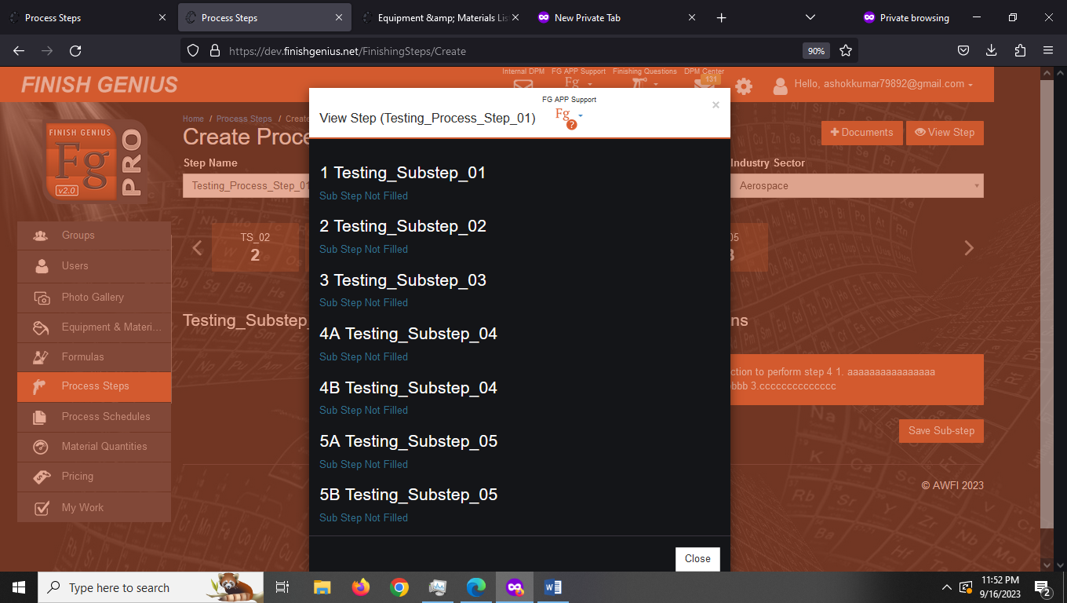
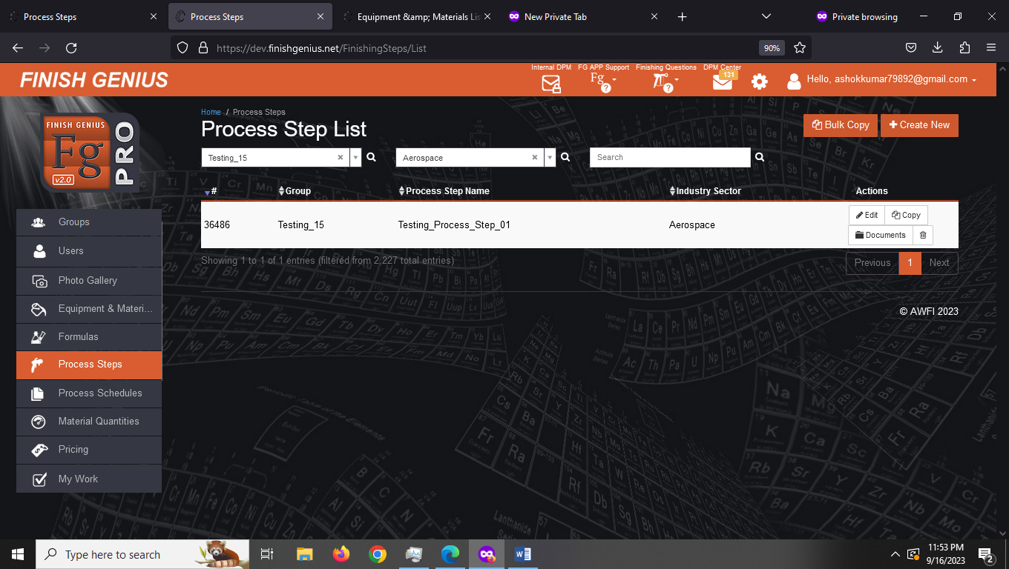

Similarly, We can create More Process Steps
We can also copy this Process step to other step
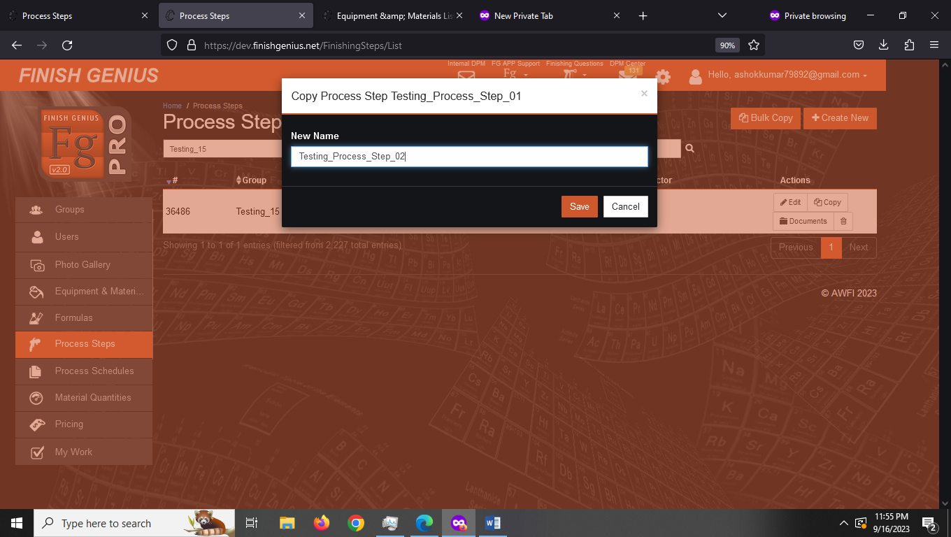
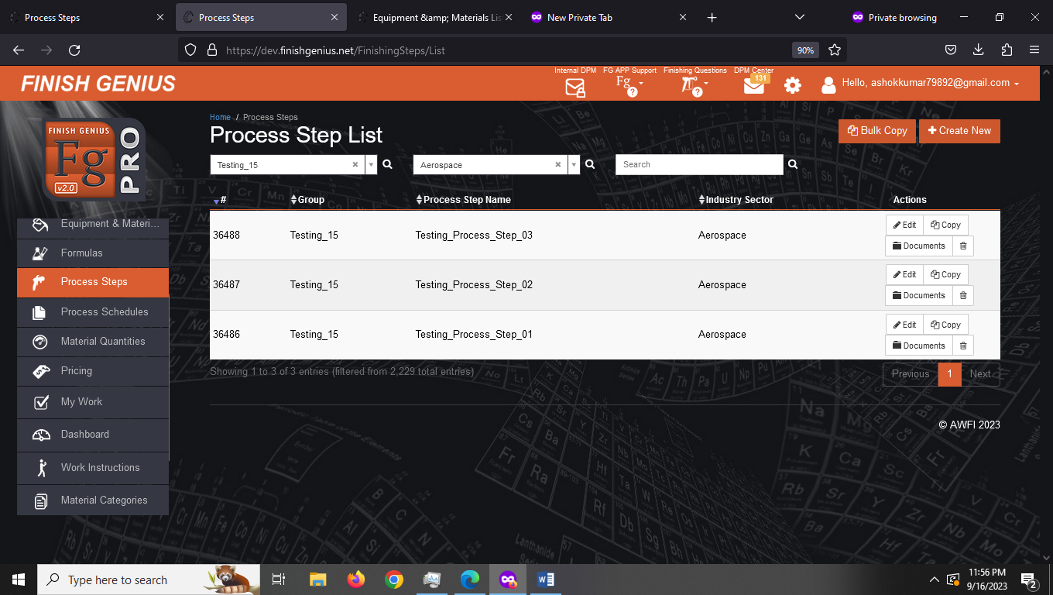

4. Bulk Copy Process Steps to other group
Step1 – Select the steps you wish to copy to other group
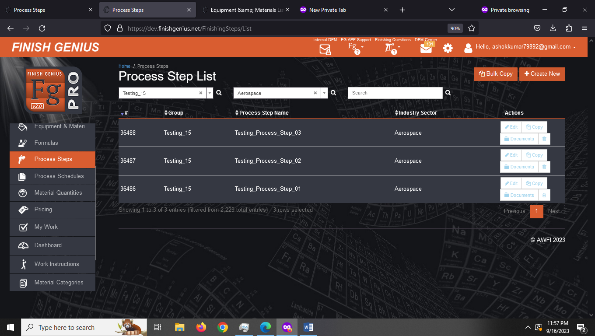

Step-2 Click on Bulk Copy
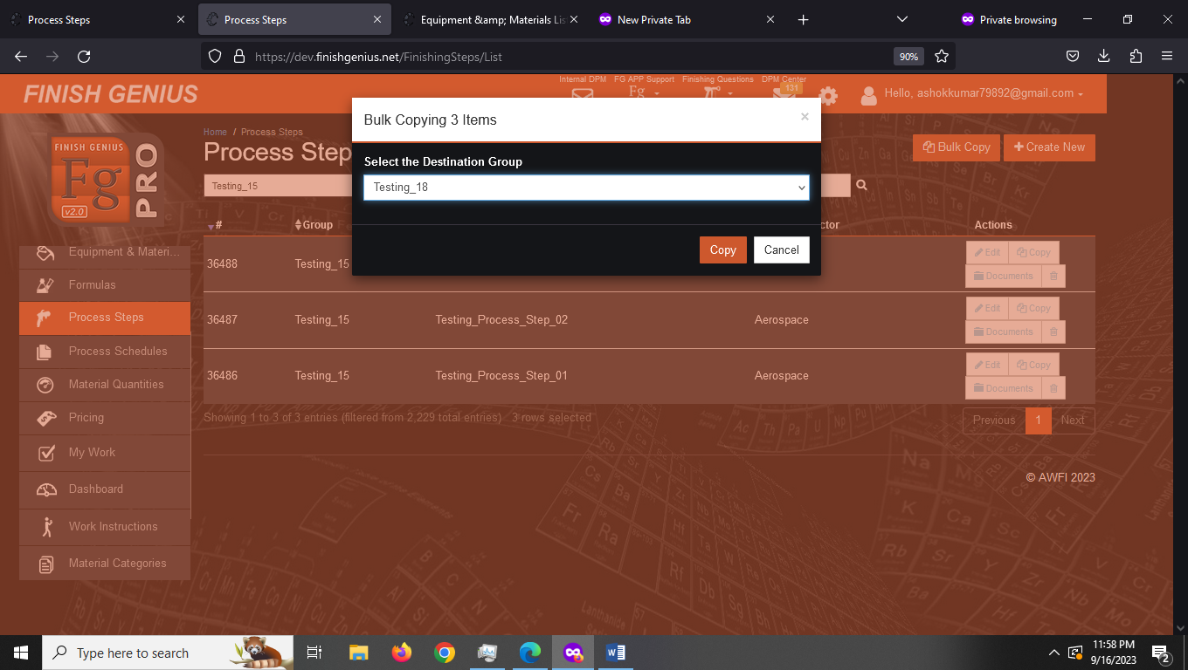
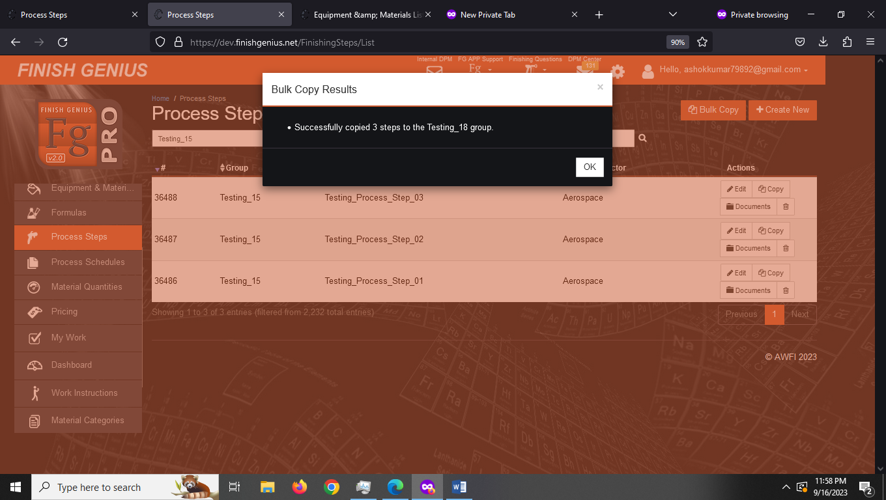

Conclusion
[Note: Process Step has directly dependency on sub steps setup]
1. Checking all the process steps are same in prod and dev environment
Process: Randomly checked 5 clients all the process steps are same in prod and dev
Status: Successful
2. Industries for which we can create process steps are as follows
1. Aerospace
2. Automotive
3. Construction
4. Food
5. Heavy Manufacturing
6. Marine
7. Wood
3. Create New Process Steps
3.1 Creating sub step setpup
Status: successful for both user and admin
3.2 Crate Process steps, View Process Steps, Copy Process Step, Bulk Copy Process Steps
Status: Successful

